Participant-centred planning: 6 steps for gender balance activities in tech
Running activities to try to attract young people into tech takes time and energy, and it’s not always clear what activities really work. Our team (University of Stirling, Edinburgh Napier University, Ada Scotland Festival, SDS) have developed a framework to support organisers planning these activities. Our aim is that by using the framework you will create a better event, and you will be able to evidence your success through embedded evaluation.
The framework puts participants at the centre: who are you trying to engage, and what is the change you wish to see in those participants following your event? We’re particularly interested in the way initiatives use people involved in the activity as role models, or representations of possible future selves, for participants.
The framework is based on research carried out in 2021 with event organisers and young women studying tech. Scottish Government funded the project.
How to use this framework: On page 2 you will find the best practice card which summarises the framework. Follow the arrows to move through each aspect as you plan your activity. Pages 3-8 have checklists to help you think about each aspect of the planning in more detail. The comments are quotes from our previous research. Lastly, the Quick Questions on page 9 encourage you to record your own answers to the questions raised. A split-window approach works well, keeping the quick questions visible all the time, and using the other part of the window to scroll to the relevant checklist.
If you use this framework we’d love to hear from you: Contact Professor Carron Shankland: carron.shankland@stir.ac.uk if you have a question or for further information, or to tell us about your usage and what you think of the framework.

Project Team:
Camilla Barnett, Carron Shankland (University of Stirling)
Sally Smith, Ella Taylor-Smith (Edinburgh Napier University)
Matthew Barr (Ada Scotland Festival)

Participant-centred planning: 6 steps for gender balance activities in tech
1. Aims (p3)
Strategic aims - what has inspired you to do this?
Participant aims -what will your participants get out of it?
Evaluation -how will you find out what your participants got out of it?
2. Participants and inclusion (p4)  Who is the activity aimed at?  What do participants need from you?  Choose time to suit participants.  Evaluation: What data will you need to collect about participants?  (Privacy policy) | 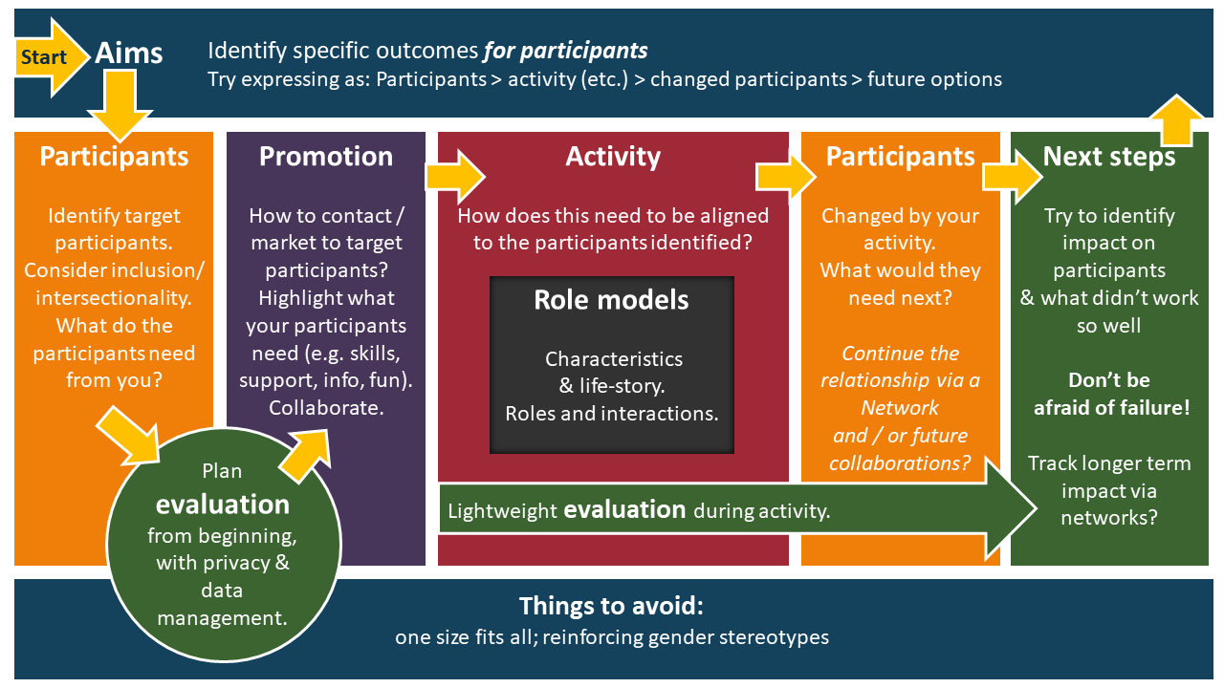 |  |  | 6. Next steps (p8)  What impact did your activity have on participants?  What do they need next? (Feeds into Aims for next activity)
3. Promotion (p5)  How will you contact participants?  Highlight how your activity meets the participants' need:[e.g. skills, support, info]  Evaluation: What worked to reach your target participants? |  | 4. Activity (p6)  Fulfilling participants’ needs.  Evaluation: can you include a lightweight feedback mechanism in your activity? | 5. Role Models (p7)  Could be examples (e.g. female students; women /women of colour working in tech).  Could be role models by encouraging participants and taking them seriously.

Aims
- Aims
- Strategic aims - what has inspired you to do this?
- Participant aims -what will your participants get out of it?
Identify | Examples
- What specific positive impacts will the activity have on the participants?  - Have you identified their needs?  - Try expressing as: Participants > activity > changed participants > future options  - How the objectives relate to institutional strategies and government policies.  - Helpful for funding and other support.  - Who is working in this area in your organisation?  - Interested partners (e.g. industry, schools, 3rd sector). | Participant aims  - to raise awareness / inform  - to raise aspirations / inspire  - to influence career / course choice  - to build confidence / support  - to provide skills  Strategic aims  - Improve gender balance in subjects;  - Support and retain female students;  - Widening access and inclusion;  - “Inspire and empower”;  - Engage with wider/ local community;  - Build ties with industry;  - Digital tech industry needs more women.
What worked for participants? | Tips / ideas from organisers
- Community (e.g. being around women, rather than being in a minority);  - Useful information; Gaining skills;  - Inspiration and support;  - Finding a place for themselves in tech;  - Seeing women succeed in digital;  - Seeing the wide variety of careers and roles;  - Finding out about the diverse backgrounds and routes in of tech workers. | - Describe aims in terms of what participants will get out of it *at the beginning of planning*.  - Involve potential participants in planning.  - Be really clear about what the event is about.  - Highlight strategic aims in comms and reports.  - Helpful to have enthusiasm and support from leadership and colleagues.
Evaluation | Comments
- Centre evaluation on the participant aims: understanding what participants got out of it and whether it met their needs.  - Challenge of evaluating strategic aims,  e.g. if your event is aimed at S2 girls and your aim is to increase computing/digital applicants to your institution, it will be hard to prove a connection.  - If you’re collaborating, surface all aims and evaluation requirements asap (e.g. by going through this framework together). | “It is generally quite difficult to fit into a course where I am one of about 4 girls who attend it, and I think having more female peers would make me feel so much more confident and comfortable in my studies.”  “Even though it was the main area I was interested in, due to my school being unable to host computing/design and technology, I applied for marketing instead. Only to change course once I got to uni.”

Participants and inclusion
2. Participants and inclusion
Identifying target participants | Including
- Is the initiative specifically aimed at girls/ women / non-binaries?  - Or balanced mixed genders?  - Any specific age group or life / education phase?  - Local? Urban? Rural? International?  - Consider diversity and intersectionality, e.g. gender identity, ethnicity, disability, neuro-diversity, socioeconomic background. | - How to include under-represented groups? (E.g., location, timing, marketing, use of networks)  - Diversity in role models and staff, including organisers.  - Digital divides?  - Transport (if you’re inviting people in).
What worked for participants? | Tips / ideas from organisers
- Diverse role models.  - Positive support.  - Opportunities for learning, fun, creativity, and social good.  However, participants could be put off  - if they felt patronised,  - or that gender stereotypes were being reinforced,  - or that they would get a job based on their gender, rather than their skills. | - Can be possible to specify gender-balanced groups when working with schools.  - Consult teachers for good times of year.  - Be aware of different school holidays across Scotland.  - Get help with admin and comms.  - Pay student helpers.
Evaluation | Comments
- Plan data management (privacy and consent) carefully and early.  - What data will you need to collect about your participants?  - Collect demographic data sensitively.  - Consider using a collection of methods, from sticky notes to focus groups.  - What did participants take home from the event?  - What do they need next? | “Sometimes it's challenging if you're the only woman in a group. I find it quite intimidating, and often get interrupted or overlooked when having a discussion.”  “I ran a Black Girls Code event which featured a bingo night to raise money for the organisation, we had black women in STEM speakers who shared their stories and it was a really positive evening!”  "As a trans woman I'm scared as my experience with men in the field hasn't been the most pleasant when it comes to my gender identity."  "People are really surprised by what I study. Especially at my age."  “Our moto is Collaboration is Key and we truly believe that a bringing everyone together under one roof increases the impact and has the best outcome for all parties.”

Promotion
3. Promotion
Reaching target participants | Including
- How will you contact participants?  - How to contact / market to target participants?  - Plans for inclusion:  - Who might not hear about it?  - Who might not feel welcome?  - Use networks.  - Collaboration and co-promotion. | Highlight how your activity meets the participants' need, e.g. skills, support, info  - Emphasise what they will get out of your event.  - Examples from organisers: “to understand how a recruitment process works, or the types of jobs they might be able to get in a specific sector, or a specific organisation, or they're coming to gain skills like employability skills, and they're able to practically apply them in their own setting or in their own life.”
What worked for participants? | Tips / ideas from organisers
- Involving peers and near-peers in promotion.  - Working with schools.  - Opportunities and competitions.  What didn’t work for schools?  - Afterschool online events.  - Events in school holidays | - Specify 50% female participants for any event.  - Emphasise collaboration, socially useful outputs, & creativity, rather than competition.  - Build relationships with local schools.  - Invite people personally where possible.
Evaluation | Comments
- What data do you need to collect within registration?  - Plan into privacy policy, from beginning and include in registration page for online registration (e.g. Eventbrite).  - Or other ways to find out about who attended the event.  - How did participants find out your initiative?  - What persuaded them to get involved? | “it inspired me to continue my journey as a woman in tech.”  “competitions, lectures, and mentoring come together to show girls what it's like to study computing at uni.”  “It is very important to me that I work for a purpose-driven organisation involved in using tech for social good. My impression is that this true of other women, more so than men.”  “I wish there was more of a push for sustainable technology, or for students to build and learn how to use environmental thinking in their tech projects..”

Activity
4. Activity
Typology options: activities | Environment
- Guest speaker(s)/ Panel / Q&A  - Workshop / interactive demos  - Online festival  - Competition  - Peer support network  - Mentoring  - Course / training / summer school etc.  - Marketing materials | Where to hold the activity? E.g.,  - Welcome people into your environment (e.g. uni)  - Go to theirs (e.g. school)  - 3rd party space (e.g. science festival)  - Industry  - Online equivalents  Online events extend availability beyond the local, but can be harder to engage and support each other. Some platforms have privacy, security and access issues for some orgs.
What worked for participants? | Tips / ideas from organisers
- Students preferred taking active, rather than passive roles.  - They valued learning new skills;  - And the fun and confidence boost of competitions;  - Finding out about other people’s work and being inspired;  - Content aligned with their values (e.g. creating apps for social good);  - Community. | - Images of tech women in everyday environment.  - Ice-cream. Music.  - Collaborate—huge support for this from industry and government, lots of initiatives and sponsorship around.  - Tailor activities / material to specific groups (girls, young children, neurodiverse participants), based on research / expert advice.  - Ask participants if they need any adjustments.  - Think about next steps for participants, e.g. what kind of info will they need next?  - Don’t be afraid of failure.
Evaluation | Comments
- Integrate light feedback mechanism into event.  - What impact did the activity have on participants?  - What didn’t work and why? | “Generally leave having learned something and feeling inspired. These events are very inclusive, friendly and inspirational.”  “We never won it, but we always managed to do really well. I had lots of fun with this competition... I tended to be the one who figured out how to solve the problem first, which made me feel really intelligent and worthy of being in my degree.”  “Workshops are the best because you can see yourself building the end result even if someone is holding your hand. Often times smaller workshops or more interactive ones were more impactful and especially if they were female focused.”

Role Models
5. Role Models
Who are they? | What do they do?
Considerations: gender, age, ethnicity, background, achievements, aspect (e.g. friendliness, positivity).  - Diverse people working in the tech industry;  - Diverse professors and students;  - Staff helping out, e.g. lecturers, researchers, teachers (any gender). | Demonstrate that women can be successful in computing and tech industries,  - by example (if female);  - by taking participants / girls seriously (e.g. helping them develop a skill, answering lots of questions).  Also, offer support and encouragement and create friendly communities.
What worked for participants? | Tips / ideas from organisers
- Seeing women succeed and hearing how they got there.  - Finding out about real jobs and opportunities.  - Being encouraged and mentored.  - Organising their own communities and networks.  - A change from being in male-dominated environments. | - Integrate, e.g. female student ambassadors at open days; women in history of tech when learning concepts.  - Boys don’t seem to mind if speakers are male or female.  - Role modelling enforces your endeavour, rather than being an end in itself.  - Invite people personally.  - Consider yourself a role model.
Evaluation | Comments
- Ask helpers how you can reward them.  - Get feedback from guests and helpers too.  - Establish relationships and networks, for support, evaluation, and future participation. | “They have a friendly personality. Don't make the occupation feel out of reach and don't talk 24/7 jargon.”  “I enjoyed this because they had very different backgrounds and neither had set out to work in STEM so their stories and experiences were interesting.”  “It made me a lot more confident as a woman wanting to pursue a career in a rather male dominated field.”  “Guest speakers are the most impactful when they talk about what they had to do to get where they are and often when they don't come from a digital technology background how they broke into it.”  “Look, these are the jobs, if you haven't heard about them already. These are all the amazing women doing them.”

Next steps
6. Next steps
Wrapping up | Future
- Thank everyone involved.  - Get feedback from everyone, not just participants.  - Find out what everyone got out of it | - What practical next steps can you help participants with?  - What do you need to change next time?
What worked for participants? | Tips / ideas from organisers
This is what you need to find out!  Also: what didn’t work so well? | - Find out what participants need next and address this in your next initiative.  - “Coming to this event is really good for role modelling, but what are the next steps for  that person, that individual?”  - “Whenever we have really positive feedback on our more successful events, it's always been somebody, whoever attends, is going to get something out of it…So being really clear about what it is that people will be able to take home, we feel contributes to the success.”
Evaluation | Comments
- Can be hard to evaluate role modelling events:  - Often ad hoc and poorly resourced;  - Run out of energy by the end;  - Negative comments can be deflating;  - Worries about GDPR: collecting demographic or contact data.  - Incentives for completing surveys (e.g. prize draw).  - Keeping in touch, e.g. following on LinkedIn for older participants, can reveal career progress. | “She just completely blossomed from where she was into someone that's so much more confident.”  “We found that the girls are just so much more interested if there was something which they could apply to real life rather than just kind of play with the tool.”  “The topics of the speakers were often tailored to try and make the subject more relatable - for example we had a talk about the maths of love - I found these talks annoying and cringy. I much prefer talks about technical new initiatives.”  “I attended Women in Computing meetings at my local college, which were very helpful as I felt a bit isolated being the only female in my class.”

Quick questions
Record your answers on the right, so that you can refer back to them for evaluation etc.
0. | Project name, project date, and organiser (enough detail for you to be able to identify it)
1. | - What will your participants get out of your activity?  - How does it meet their needs?  - How will they be changed?
2a | Who do you want your participants to be? Who is your activity aimed at?
2b | What data do you need to collect about your participants?  - Demographic data?  - Contact data?  - Feedback about the event?  - What they need next?  (Write privacy policy)
3. | How will you promote your activity?  - Main message (what participants will get out of it)  - Channels  - Networks
4. | - What do you need to think about to align your activity with your participants and fulfil (some of) their needs?  - How can gather feedback within the activity?
5. | - Who are your role models?  - How will your participants interact with them?
6. | - What did your participants get out of the activity?  - What do they need next?  - What needs to be changed/ improved / addressed next time?

At the minimum, your privacy policy needs to cover: 1) Data Controller’s details and a way to contact them. 2) Legal Basis/es (as provided in Data Protection compliance check form). 3) Who personal data is shared with. 4) If personal data is transferred outside the UK. 5) How long data will be retained or the rationale for retaining data. 6) If any automated decision making or profiling is taking place.

